***Assignment of Tally ERP9***



***Amarpreet***

***GU-2018-1069***

***BBA 4***

* **Introduction to ERP9:** Tally.ERP9 is one of the most widely used financial software. Tally.ERP9 reports can help a business owner make informed decisions to increase efficiency, reduce costs and organize business operations. It provides a Comprehensive solution for accounting and inventory needs of business.

It provides the capability to generate fully accurate tax returns in matter of minutes and is also capable of extracting, interpreting and presenting financial data.

* **Features of ERP9:** The features of tally erp9 are many. Some of them have been discussed below;

1. **Simplicity:** It is easy to setup, simple to use and is designed to simplify the complex day to day activities associated in a enterprise.
2. **Auditor’s Edition:** It is offered by Tally ERP9, which provides auditing and compliance capabilities exclusively for chartered accountants.
3. **Remote Access:** It provides its users with remote capabilities to access the data from any location whatsoever at any point in time.
4. **Power:** It allows users to maintain multiple companies and with unlimited levels of classification & grouping capabilities.
5. **Flexibility:** It comes with a flexible option to generate instant reports for any given period, either month or year or at any given point of time besides providing the facility to switch between Accounting & Inventory reports of the same company or between companies.
6. **Speed:** It provides the capability to generate instant and accurate reports, which assists the management to take timely and correct decisions for overall productivity and growth of organization.
7. **Control Centre:** works as an interface between the user and Tally.ERP9 installed at different sites and enables the user to centrally configure and administer site or user belonging to an account.
8. **Accounting without codes:** It allows accounting with the regular names without any account codes.

* **How to create company:**

**Step 1. To open Tally Software:** Double click on tally icon from your desktop.

**Step 2.To go to create company screen:** To do this select create company from the company info. Menu using up and down arrow key and press Enter key.

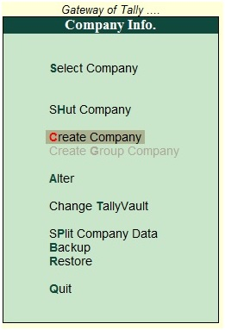

**Step 3. To fill up the details in company creation screen:** In this company creation screen, you should enter all the details of the company that you been asked for.

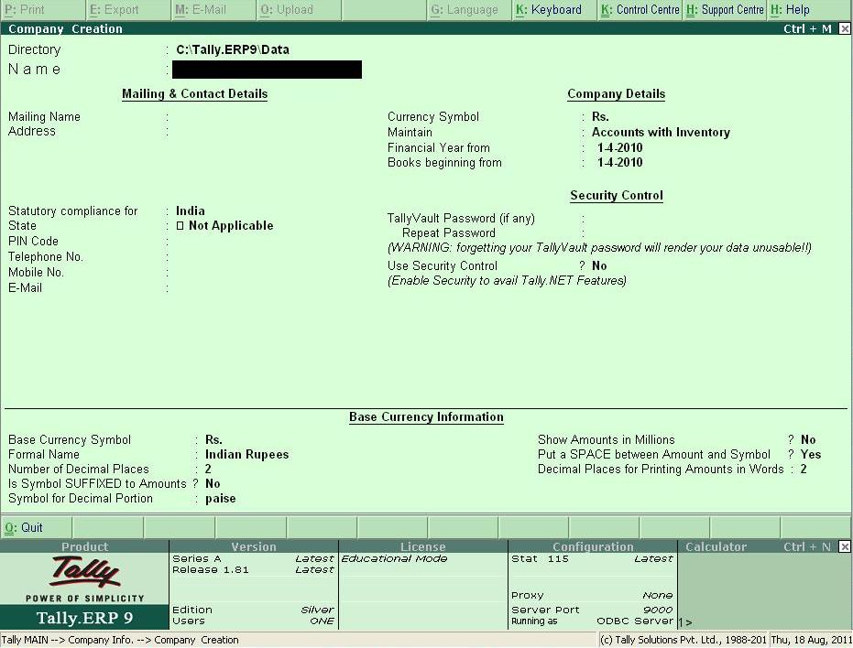

**Details to be filled in co. creation screen**

* Directory
* Name
* Primary mailing details: Mailing name, Address, Country, State, Pincode
* Contact details: Phone no., Mobile no., Fax no., Email, Website
* Books and financial year details: Financial year begins from, Book beginning from
* Security control: Tally vault password (if any)
* Use security control?
* Base currency information: Base currency symbol, Formal name, Suffix symbol to amount? , Add space between amount and symbol? , Show amount in millions? , Number of decimal places, Word representing amount after decimal, Number of decimal places for amount in words
* To save the details entered in company creation screen
* **How to create ledgers:** When we create company, 2 ledgers are already created by default that are; Cash account and Profit & Loss account.

All other ledgers have to be manually created before we can begin work in tally.

There are two ways to create a ledger in Tally:

1. First, a single ledger.
2. Second, multiple ledger

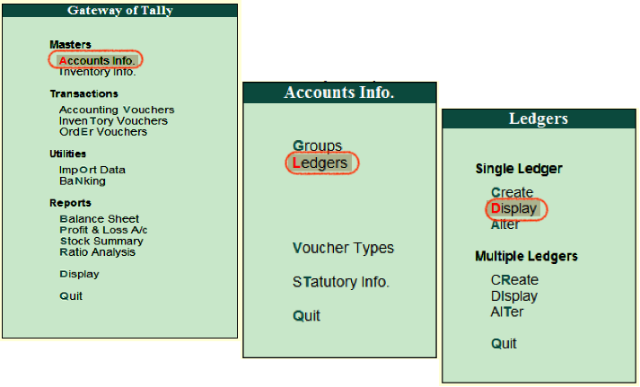

* **Method 1: Single ledger**

Step 1: From gateway of tally, go to accounts info

Step 2: Go to ledger

Step 3: Under single ledger, select option create

Step 4: Fill the particulars in ledger creation screen displayed: Name (for e.g. Furniture a/c)

* Under: Every ledger requires a group to operate in
* Inventory values are affected.
* Mailing details like name, address, country, bank details.
* Tax registration details includes, PAN/IT No., Registration type, GSTIN/UIN., Set/Alter GST details
* Opening balance: Amy balance of the ledger which is being carried forward from the previous year will have to be entered as the opening balance.

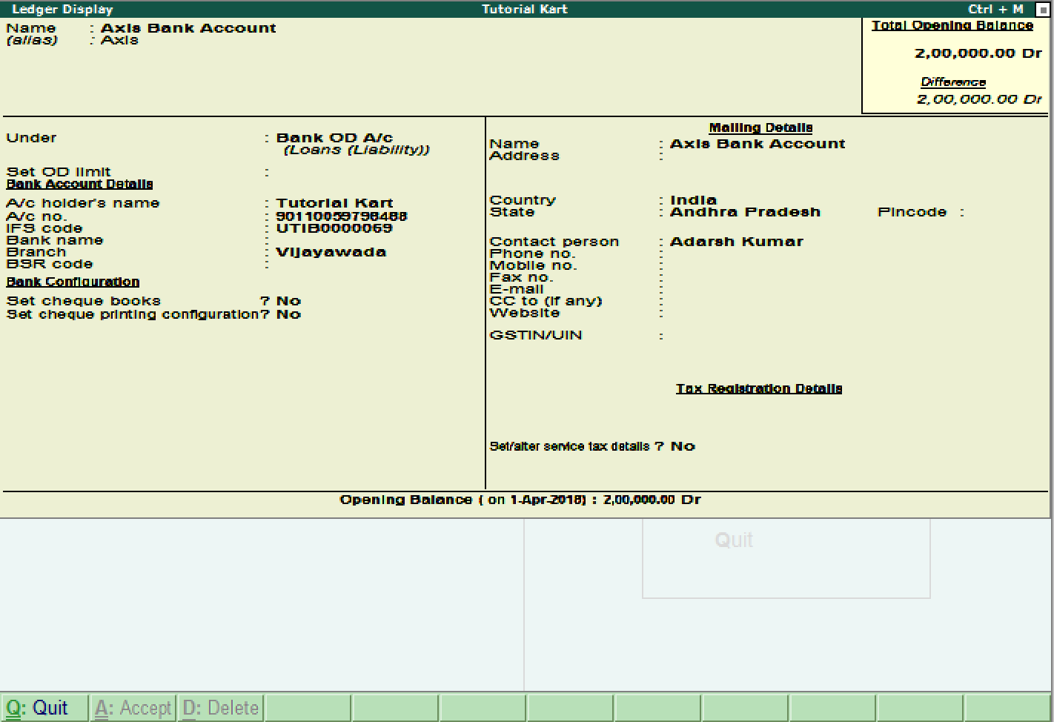

* **Method 2: Multiple ledgers**

Step 1: From gateway of tally, go to accounts

info

Step 2: Go to ledger

Step 3: Select option create

Step 4: Fill the particulars in ledger creation

screen:

* Under group: In this, furniture a/c, electrical and fittings will be under fixed assets group, investment in shares, investment in fixed deposit account under investment group, etc. This works well if we create ledgers under only one group. This type of ledger creation is also not useful for creating Sundry debtors ledger and Sundry creditors ledger as we have to also fill up GST details of individual creditors and debtors while creating ledger account for them.

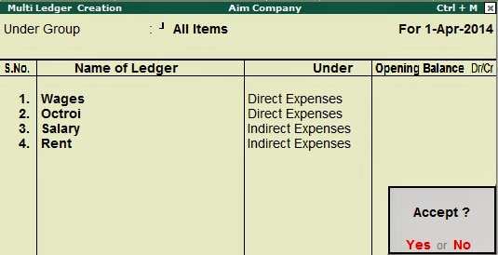

* **Activation of different features:**

1. Accounting features
2. Inventory features
3. Statutory & Taxation features

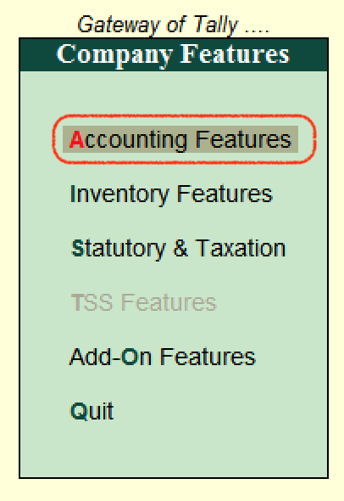

1. Accounting features are divided into 6 sections which are as follows:
2. General
3. Outstanding management
4. Cost/ Profit center management
5. Invoicing
6. Budgets/ scenarios management
7. Other features
8. Inventory features are subdivided into 7 functions which are as follows:
9. General
10. Storage and Classification
11. Order processing
12. Invoicing
13. Purchase management
14. Sales management
15. Other features
16. Statutory & Taxation features:
17. Goods and Services Tax (GST)
18. Excise
19. Value added tax (VAT)
20. Tax deducted as source (TDS)
21. Tax collected at source

* **Financial statements:** It includes the following four major statements, which form a part of statutory requirements for companies in most countries.
* **Balance sheet**
* **Profit & Loss a/c**
* **Trial Balance**
* **Receipts & Payment a/c**

**Steps to prepare balance sheet:**

* Preparing ledger accounts: This is because a ledger account may have several transactions and there is no way that journal book will tell you the current balance of each account.

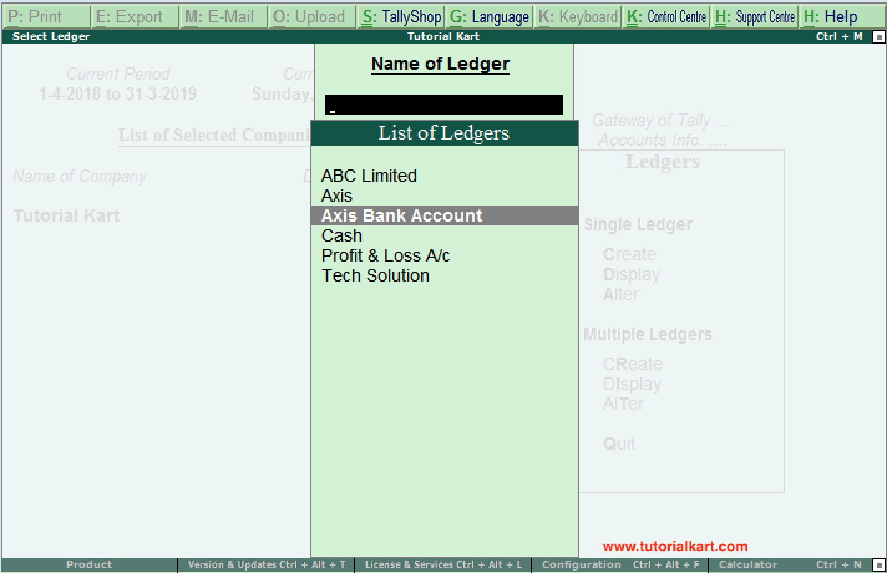

* Create trial balance: The format of trial balance consists of the Debit column and Credit column in which the closing balance of each ledger accounts will be posted.

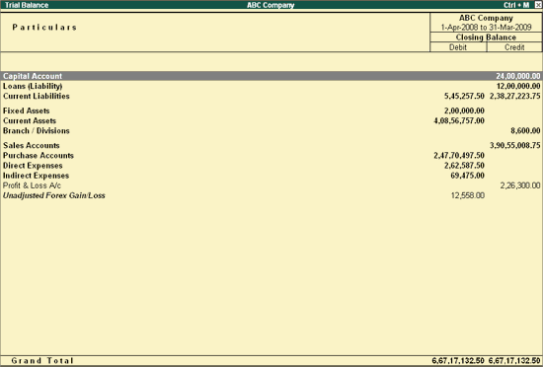

* Preparing trading and profit & loss a/c: Trading and profit & loss a/c consists of all the ledger a/c having a nature of the purchase, sales, direct expenses and income, indirect expenses and income. While preparing trading and profit & loss

a/c you need to post only the ledgers belong to above nature.

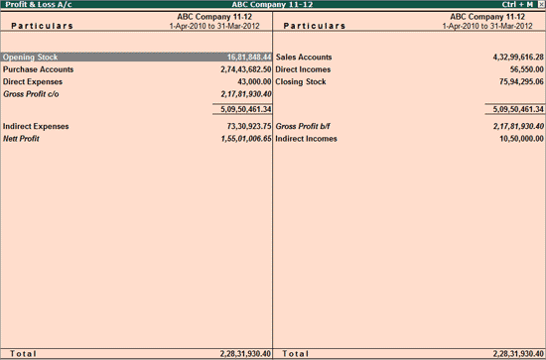

* Prepare balance sheet: Once you have captured all details into balance sheet, the assets side should be equal to the liabilities side of balance sheet. Only then, your balance sheet is arithmetically correct.